Module 3: Git and Jenkins Assignment I

Problem Statement

Hooli Co. has put Harry and Kane to implement a new set of features in their feature software. Both started working separately, making their own copies of the same source code. Now, it has become difficult for them to track the changes they’ve made in the original code, and they are finding it

difficult to merge their code together.

Action Items

* Create two separate branches from master
* Make changes in the same function of the source code in both the branches
* Merge branch1 into the master
* Try and merge branch2 into the master (merge conflict should arise)
* Install a merge tool of your choice and resolve the merge conflict using   
  git mergetool command

Solution

1. Committed 3 files to the library with commit name m1

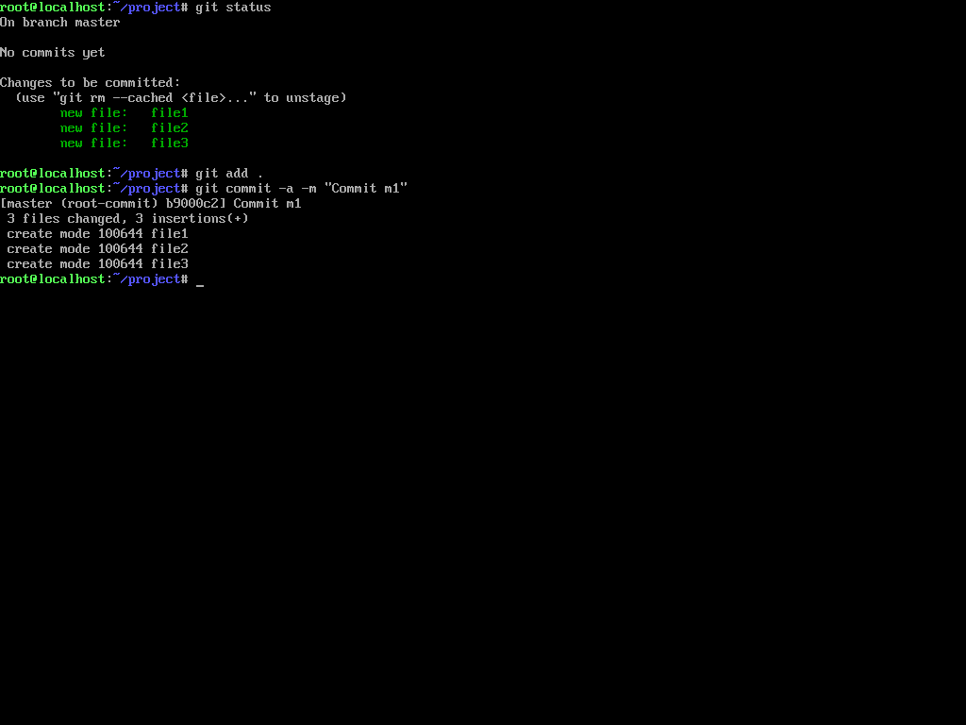

1. Created two branches feature1 and feature2

1. Made changes to the file **file1** in the branch feature1

1. Made changes to the file **file1** in the branch feature2

1. Merging feature1 to master
2. Merging feature2 to master. This led to a conflict

1. Resolving using git mergetool

1. Committing the conflict resolved

